Day 4 Assignment

1.Use the rest countries API url -> https://restcountries.eu/rest/v2/all and display all the country flags in console

Ans

//Set up Http Request

var xhr = new XMLHttpRequest();

//create and send Get request

//GET,POST,PUT,DELETE,

// Second =>ENdpoint of the url:server url

xhr.open("GET", "https://raw.githubusercontent.com/rvsp/restcountries-json-data/master/res-countries.json");

// set up our listener to process the request

xhr.onload = function () {

//process the request and server will return the data

if (xhr.status >= 200 && xhr.status < 300) {

var t = JSON.parse(this.response);

// console.log(t);

// document.write(t);

for(i=0;i<t.length;i++)

{

console.log(` the flag of ${t[i].name} is ${t[i].flag}`);

}

} else {

//it should not give you data

console.log("Data is not available");

// document.write(t);

}

};

xhr.send();

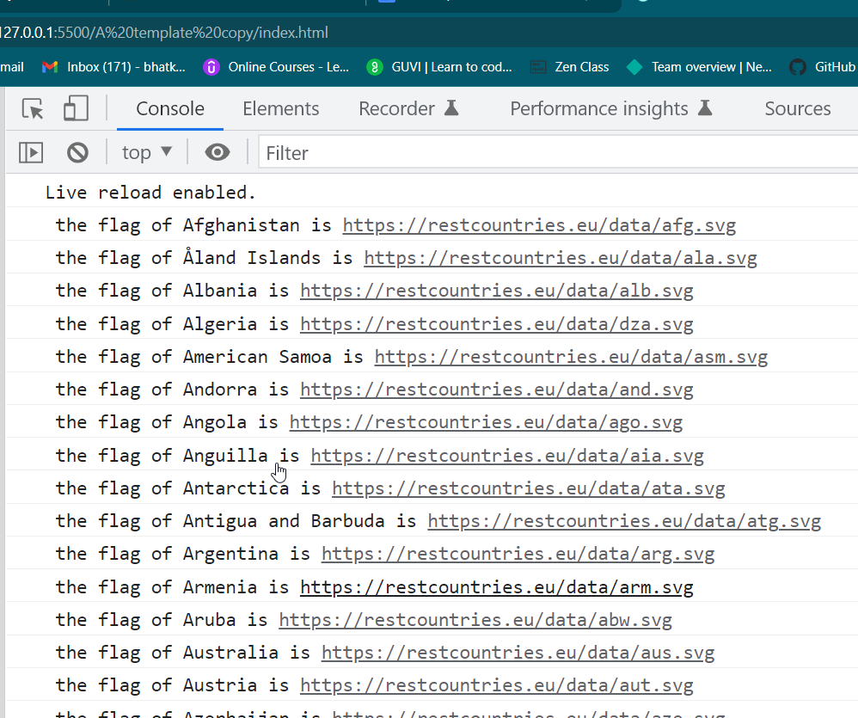

2. Use the same rest countries and print all countries name, region, sub region and population

Ans;

//Set up Http Request

var xhr = new XMLHttpRequest();

//create and send Get request

//GET,POST,PUT,DELETE,

// Second =>ENdpoint of the url:server url

xhr.open("GET", "https://raw.githubusercontent.com/rvsp/restcountries-json-data/master/res-countries.json");

// set up our listener to process the request

xhr.onload = function () {

//process the request and server will return the data

if (xhr.status >= 200 && xhr.status < 300) {

var t = JSON.parse(this.response);

console.log(t);

// document.write(t);

for(i=0;i<t.length;i++)

{

console.log(`

Name : ${t[i].name} ,

Region : ${t[i].region},

Sub-Region : ${t[i].subregion},

Population : ${t[i].population} . `)

}

}

else {

//it should not give you data

console.log("Data is not available");

// document.write(t);

}

};

xhr.send();

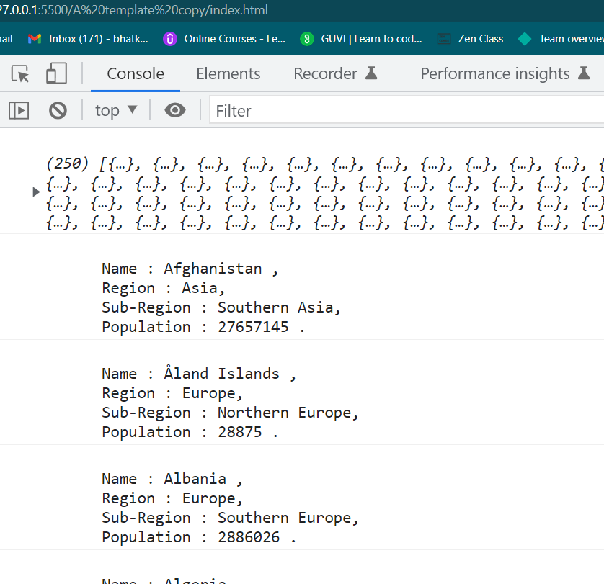

3.How to compare two JSON have the same properties without order?

var obj1 = { name: "Person 1", age:5 };

var obj2 = { age:5, name: "Person 1" };

Ans. by using _.isEqual function we can compare two json having same property without order.

<!DOCTYPE html>

<html lang="en">

<head>

<meta charset="UTF-8">

<meta http-equiv="X-UA-Compatible" content="IE=edge">

<meta name="viewport" content="width=device-width, initial-scale=1.0">

<script src =

"https://cdnjs.cloudflare.com/ajax/libs/underscore.js/1.9.1/underscore-min.js">

</script>

<title>Document</title>

</head>

<body>

<script type="text/javascript">

var obj1 = { name: "Person 1", age:5 };

var obj2 = { age:5, name: "Person 1" };

console.log(_.isEqual(obj1, obj2));

</script>

</body>

</html>

